ΠΜΣ ΑΝΑΠΤΥΞΗ & ΑΣΦΑΛΕΙΑ ΠΛΗΡΟΦΟΡΙΑΚΩΝ ΣΥΣΤΗΜΑΤΩΝ
Neo4J Graph Database
Συστήματα Διαχείρισης Δεδομένων Μεγάλης Κλίμακας
ΟΝΟΜΑ | ΕΠΩΝΥΜΟ | ΑΜ
ANGELIKI | KAPOGIANNI | p3312508
ALEXANDROS | KAZOS | p3312506

Δημιουργία Σχήματος Γράφου
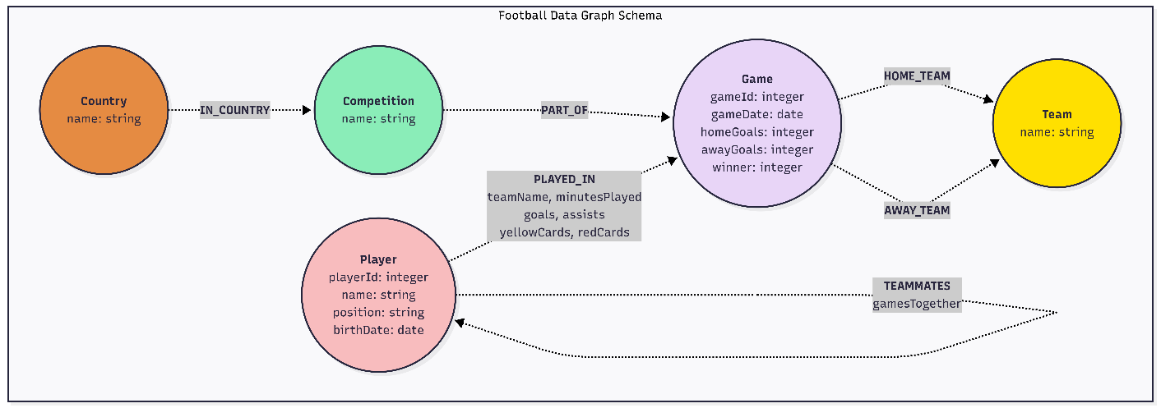
Διαγραμματική αναπαράσταση του γράφου και την περιγραφή των κόμβων και των σχέσεων.

Η Δημιουργία σχήματος πραγματοποιήθηκε με το mermaid και ο κώδικας για την δημιουργία του είναι ο παρακάτω:
flowchart TB
subgraph subGraph0["Football Data Graph Schema"]
Country(("<b>Country</b><br>name: string"))
Competition(("<b>Competition</b><br>name: string"))
Game(("<b>Game</b><br>gameId: integer<br>gameDate: date<br>homeGoals: integer<br>awayGoals: integer<br>winner: integer"))
Team(("<b>Team</b><br>name: string"))
Player(("<b>Player</b><br>playerId: integer<br>name: string<br>position: string<br>birthDate: date"))
end
Country -. <b>IN_COUNTRY</b> .-> Competition
Competition -. <b>PART_OF</b> .-> Game
Game -. <b>HOME_TEAM</b> .-> Team
Game -. <b>AWAY_TEAM</b> .-> Team
Player -. <b>PLAYED_IN</b><br>teamName, minutesPlayed<br>goals, assists<br>yellowCards, redCards .-> Game
Player -. <b>TEAMMATES</b><br>gamesTogether .-> Player

style Country fill:#e58b42
style Competition fill:#8aedb8
style Game fill:#e8d5f7
style Team fill:#ffe000
style Player fill:#f8bcbe

Δημιουργία Γράφου
Κώδικας Cypher που γράψατε για να δημιουργήσετε τον γράφο και να φορτώσετε τα δεδομένα.
// ============================================================================
// STEP 1: Create Constraints and Indexes
// ============================================================================

// Create unique constraints (ensures data integrity)
CREATE CONSTRAINT game_id_unique FOR (g:Game) REQUIRE g.gameId IS UNIQUE;
CREATE CONSTRAINT player_id_unique FOR (p:Player) REQUIRE p.playerId IS UNIQUE;
CREATE CONSTRAINT team_name_unique FOR (t:Team) REQUIRE t.name IS UNIQUE;
CREATE CONSTRAINT competition_name_unique FOR (c:Competition) REQUIRE c.name IS UNIQUE;
CREATE CONSTRAINT country_name_unique FOR (co:Country) REQUIRE co.name IS UNIQUE;

// Create indexes for performance optimization
CREATE INDEX game_date_index IF NOT EXISTS FOR (g:Game) ON (g.gameDate);
CREATE INDEX player_position_index IF NOT EXISTS FOR (p:Player) ON (p.position);
CREATE INDEX player_name_index IF NOT EXISTS FOR (p:Player) ON (p.name);

// ============================================================================
// STEP 2: Load Data from CSV and Create Nodes
// ============================================================================

// 2.1: Create unique Country nodes
LOAD CSV WITH HEADERS FROM 'file:///FootBallData.csv' AS row
FIELDTERMINATOR ';'
WITH DISTINCT row.Country AS countryName
WHERE countryName IS NOT NULL AND countryName <> ''
MERGE (co:Country {name: countryName});

// 2.2: Create unique Competition nodes and link to Country
LOAD CSV WITH HEADERS FROM 'file:///FootBallData.csv' AS row
FIELDTERMINATOR ';'
WITH DISTINCT row.CompetitionName AS compName, row.Country AS countryName
WHERE compName IS NOT NULL AND compName <> ''
AND countryName IS NOT NULL AND countryName <> ''
MERGE (c:Competition {name: compName})
WITH c, countryName
MATCH (co:Country {name: countryName})
MERGE (c)-[:IN_COUNTRY]->(co);

// 2.3: Create unique Team nodes (from PlayerTeamName column)

LOAD CSV WITH HEADERS FROM 'file:///FootBallData.csv' AS row
FIELDTERMINATOR ';'
WITH DISTINCT row.PlayerTeamName AS teamName
WHERE teamName IS NOT NULL AND teamName <> ''
MERGE (t:Team {name: teamName});

// 2.4: Create unique Player nodes
LOAD CSV WITH HEADERS FROM 'file:///FootBallData.csv' AS row
FIELDTERMINATOR ';'
WITH row
WHERE row.PlayerID IS NOT NULL
AND row.PlayerName IS NOT NULL AND row.PlayerName <> ''
AND row.BirthDate IS NOT NULL AND row.BirthDate <> ''

WITH DISTINCT
toInteger(row.PlayerID) AS playerId,
row.PlayerName AS playerName,
row.Position AS position,
date(row.BirthDate) AS birthDate

MERGE (p:Player {
playerId: playerId,
name: playerName,
position: position,
birthDate: birthDate
});

// 2.5: Create Game nodes with basic properties
LOAD CSV WITH HEADERS FROM 'file:///FootBallData.csv' AS row
FIELDTERMINATOR ';'
WITH row
WHERE row.GameID IS NOT NULL
AND row.GameDate IS NOT NULL AND row.GameDate <> ''

WITH DISTINCT
toInteger(row.GameID) AS gameId,
date(row.GameDate) AS gameDate,
toInteger(row.HomeGoals,) AS homeGoals,
toInteger(row.AwayGoals) AS awayGoals,
toInteger(Winner) AS winner

MERGE (g:Game {gameId: gameId})
SET
g.gameDate = gameDate,
g.homeGoals = homeGoals,
g.awayGoals = awayGoals,
g.winner = winner;

// 2.6: Create relationships: Game -> Team (HOME_TEAM and AWAY_TEAM) --
LOAD CSV WITH HEADERS FROM 'file:///FootBallData.csv' AS row
FIELDTERMINATOR ';'
WITH DISTINCT
toInteger(row.GameID) AS gameId,
row.HomeTeamName AS homeTeamName,
row.AwayTeamName AS awayTeamName
WHERE gameId IS NOT NULL
AND homeTeamName IS NOT NULL AND homeTeamName <> ''
AND awayTeamName IS NOT NULL AND awayTeamName <> ''
MATCH (g:Game {gameId: gameId})
MATCH (ht:Team {name: homeTeamName})
MATCH (at:Team {name: awayTeamName})
MERGE (g)-[:HOME_TEAM]->(ht)
MERGE (g)-[:AWAY_TEAM]->(at);

// 2.7: Create relationship: Game -> Competition (PART_OF) --
LOAD CSV WITH HEADERS FROM 'file:///FootBallData.csv' AS row
FIELDTERMINATOR ';'
WITH DISTINCT
toInteger(row.GameID) AS gameId,
row.CompetitionName AS compName
WHERE gameId IS NOT NULL
AND compName IS NOT NULL AND compName <> ''
MATCH (g:Game {gameId: gameId})
MATCH (c:Competition {name: compName})
MERGE (g)-[:PART_OF]->(c);

// ============================================================================
// STEP 3: Create PLAYED_IN Relationships (Player -> Game with performance data)
// ============================================================================

LOAD CSV WITH HEADERS FROM 'file:///FootBallData.csv' AS row
FIELDTERMINATOR ';'
WITH
toInteger(row.PlayerID) AS playerId,
toInteger(row.GameID) AS gameId,
row.PlayerTeamName AS teamName,
toInteger(COALESCE(row.MinutesPlayed, '0')) AS minutesPlayed,
toInteger(COALESCE(row.Goals, '0')) AS goals,
toInteger(COALESCE(row.Assists, '0')) AS assists,
toInteger(COALESCE(row.YellowCards, '0')) AS yellowCards,
toInteger(COALESCE(row.RedCards, '0')) AS redCards
WHERE playerId IS NOT NULL
AND gameId IS NOT NULL
AND teamName IS NOT NULL AND teamName <> ''
MATCH (p:Player {playerId: playerId})
MATCH (g:Game {gameId: gameId})
MERGE (p)-[pi:PLAYED_IN {
teamName: teamName,
minutesPlayed: minutesPlayed,
goals: goals,
assists: assists,
yellowCards: yellowCards,
redCards: redCards
}]->(g);

// ============================================================================
// STEP 4: Create TEAMMATES Relationships (Player -> Player)
// ============================================================================

// For each game, find all players who played for the same team
// and create TEAMMATES relationships with gamesTogether count
MATCH (g:Game)
MATCH (p1:Player)-[pi1:PLAYED_IN]->(g)
MATCH (p2:Player)-[pi2:PLAYED_IN]->(g)
WHERE p1.playerId < p2.playerId
AND pi1.teamName = pi2.teamName
WITH p1, p2, COUNT(DISTINCT g) AS gamesTogether
MERGE (p1)-[tm:TEAMMATES]-(p2)
SET tm.gamesTogether = gamesTogether;

Ερώτηματα για έλεγχο εγκυρότητας του γράφου

// ============================================================================
// Verification Queries
// ============================================================================
// Run these queries to verify the data was loaded correctly

// 5.1: Count nodes by type
MATCH (n)
RETURN labels(n) AS nodeType, COUNT(n) AS count
ORDER BY nodeType;
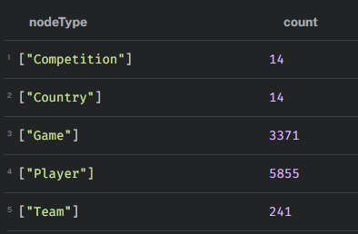
// 5.2: Count relationships by type
MATCH ()-[r]->()
RETURN type(r) AS relationshipType, COUNT(r) AS count
ORDER BY relationshipType;
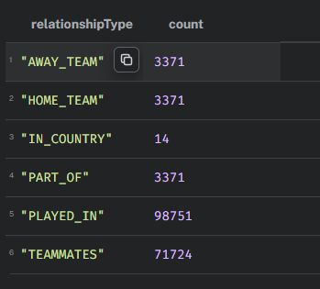
// 5.3: Sample game data verification
MATCH (g:Game)-[:HOME_TEAM]->(ht:Team), (g)-[:AWAY_TEAM]->(at:Team)
MATCH (g)-[:PART_OF]->(c:Competition)
RETURN g.gameId, g.gameDate, ht.name AS homeTeam, at.name AS awayTeam,
g.homeGoals, g.awayGoals, c.name AS competition
LIMIT 5;

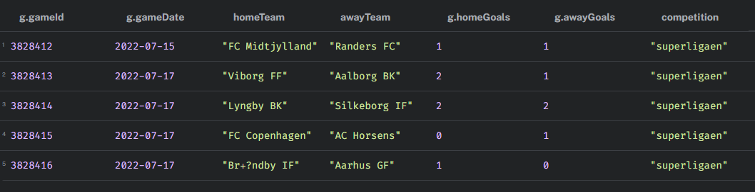

// 5.4: Sample player participation verification
MATCH (p:Player)-[pi:PLAYED_IN]->(g:Game)
RETURN p.name AS playerName, p.position, pi.teamName,
g.gameId, pi.goals, pi.assists, pi.yellowCards, pi.redCards
LIMIT 5;
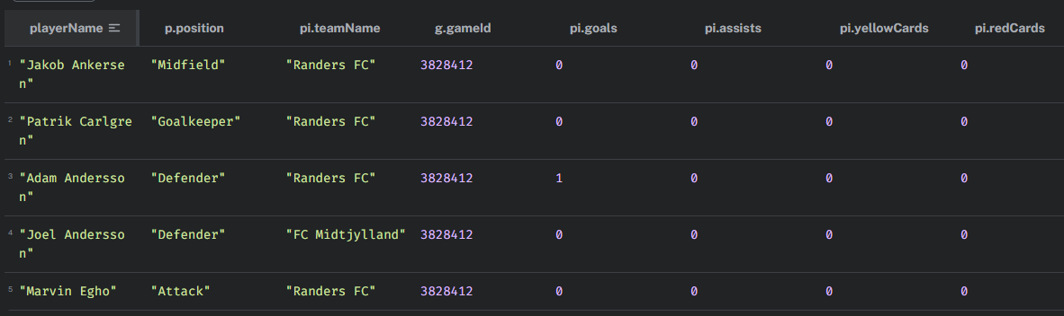
// 5.5: Sample TEAMMATES relationship verification
MATCH (p1:Player)-[tm:TEAMMATES]-(p2:Player)
RETURN p1.name AS player1, p2.name AS player2, tm.gamesTogether
ORDER BY tm.gamesTogether DESC
LIMIT 5;

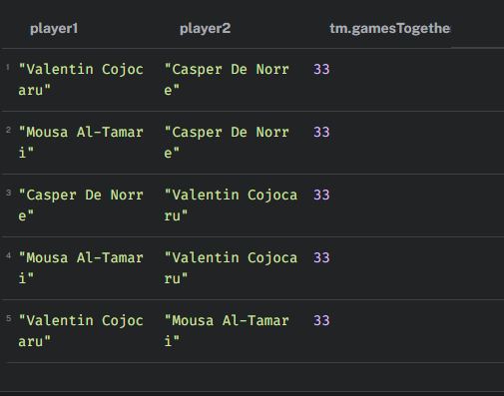
// 5.6: Verify Country-Competition structure
MATCH (c:Competition)-[:IN_COUNTRY]->(co:Country)
RETURN co.name AS country, COLLECT(c.name) AS competitions
ORDER BY country
LIMIT 10;
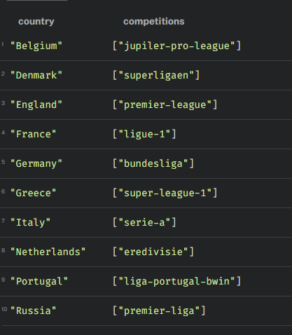

Ζητούμενα Επερωτήματα

Κώδικας Cypher για τα ζητούμενα επερωτήματα μαζί με τα αντίστοιχα αποτελέσματα.

// ============================================================================
// QUERY 1: Στατιστικά ανά πρωτάθλημα (νίκες γηπεδούχων/φιλοξενούμενων/ισοπαλίες)
// ============================================================================

MATCH (g:Game)-[:PART_OF]->(c:Competition)
WITH c.name AS competition,
sum(case when g.winner = 1 then 1 else 0 end) AS homeWins,
sum(case when g.winner = 2 then 1 else 0 end) AS awayWins,
sum(case when g.winner = 0 then 1 else 0 end) AS draws
RETURN competition, homeWins, awayWins, draws
ORDER BY competition;

competition | homeWins | awayWins | draws
bundesliga | 116 | 72 | 64
eredivisie | 112 | 82 | 66
jupiler-pro-league | 133 | 98 | 66
laliga | 129 | 89 | 71
liga-portugal-bwin | 119 | 86 | 47
ligue-1 | 131 | 101 | 78
premier-league | 142 | 93 | 71
premier-liga | 82 | 60 | 42
premierliga | 64 | 57 | 45
scottish-premiership | 99 | 62 | 31
serie-a | 123 | 97 | 80
super-league-1 | 77 | 52 | 53
super-lig | 116 | 73 | 60
superligaen | 53 | 41 | 38

// ============================================================================
// QUERY 2: Αγώνες ελληνικού πρωταθλήματος (ημ/νία, ομάδες, γκολ) ταξινομημένα
// ============================================================================

MATCH (g:Game)-[:PART_OF]->(c:Competition)-[:IN_COUNTRY]->(co:Country {name:'Greece'})
MATCH (g)-[:HOME_TEAM]->(ht:Team)
MATCH (g)-[:AWAY_TEAM]->(at:Team)
RETURN g.gameDate AS date,
ht.name AS homeTeam,
at.name AS awayTeam,
g.homeGoals AS homeGoals,
g.awayGoals AS awayGoals
ORDER BY date;

date | homeTeam | awayTeam | homeGoals | awayGoals
19/8/2022 | Volos NPS | Asteras Tripolis | 3 | 3
20/8/2022 | Atromitos Athen | OFI Crete FC | 3 | 1
20/8/2022 | PAOK Thessaloniki | Panetolikos GFS | 1 | 0
20/8/2022 | PAS Lamia 1964 | AEK Athens | 0 | 3
21/8/2022 | Aris Thessaloniki | APO Levadiakos | 3 | 0
21/8/2022 | Olympiacos Piraeus | PAS Giannina | 2 | 0
21/8/2022 | Panathinaikos Athens | Ionikos Nikeas | 1 | 0
26/8/2022 | Ionikos Nikeas | APO Levadiakos | 0 | 0
27/8/2022 | AEK Athens | Volos NPS | 0 | 1
27/8/2022 | PAS Giannina | PAS Lamia 1964 | 1 | 1
28/8/2022 | OFI Crete FC | Panathinaikos Athens | 0 | 2
28/8/2022 | Panetolikos GFS | Aris Thessaloniki | 3 | 1
28/8/2022 | PAOK Thessaloniki | Atromitos Athen | 2 | 1
29/8/2022 | Asteras Tripolis | Olympiacos Piraeus | 0 | 0
3/9/2022 | Panathinaikos Athens | APO Levadiakos | 1 | 0
3/9/2022 | Olympiacos Piraeus | Ionikos Nikeas | 3 | 1
3/9/2022 | PAS Lamia 1964 | Asteras Tripolis | 0 | 0
4/9/2022 | AEK Athens | PAS Giannina | 2 | 0
4/9/2022 | Aris Thessaloniki | PAOK Thessaloniki | 0 | 0
4/9/2022 | Atromitos Athen | Panetolikos GFS | 1 | 1
4/9/2022 | Volos NPS | OFI Crete FC | 0 | 1
10/9/2022 | Ionikos Nikeas | Atromitos Athen | 1 | 4
10/9/2022 | OFI Crete FC | Panetolikos GFS | 1 | 2
10/9/2022 | PAS Giannina | APO Levadiakos | 2 | 1
11/9/2022 | Asteras Tripolis | Aris Thessaloniki | 0 | 2
11/9/2022 | Olympiacos Piraeus | Volos NPS | 1 | 1
11/9/2022 | Panathinaikos Athens | AEK Athens | 2 | 1
12/9/2022 | PAOK Thessaloniki | PAS Lamia 1964 | 1 | 0
17/9/2022 | Atromitos Athen | PAS Lamia 1964 | 0 | 0
17/9/2022 | Panathinaikos Athens | PAS Giannina | 3 | 0
17/9/2022 | Panetolikos GFS | AEK Athens | 0 | 2
18/9/2022 | Aris Thessaloniki | Olympiacos Piraeus | 2 | 1
18/9/2022 | Volos NPS | Ionikos Nikeas | 2 | 0
18/9/2022 | APO Levadiakos | Asteras Tripolis | 1 | 1
18/9/2022 | OFI Crete FC | PAOK Thessaloniki | 1 | 1
1/10/2022 | PAS Lamia 1964 | APO Levadiakos | 1 | 0
2/10/2022 | Asteras Tripolis | OFI Crete FC | 2 | 0
2/10/2022 | Volos NPS | Aris Thessaloniki | 2 | 0
2/10/2022 | Olympiacos Piraeus | Atromitos Athen | 2 | 0
2/10/2022 | PAOK Thessaloniki | Panathinaikos Athens | 1 | 2
3/10/2022 | AEK Athens | Ionikos Nikeas | 4 | 1
3/10/2022 | PAS Giannina | Panetolikos GFS | 1 | 4
8/10/2022 | Ionikos Nikeas | PAS Lamia 1964 | 1 | 1
8/10/2022 | Panetolikos GFS | Volos NPS | 2 | 3
9/10/2022 | Aris Thessaloniki | AEK Athens | 0 | 2
9/10/2022 | APO Levadiakos | PAOK Thessaloniki | 1 | 1
9/10/2022 | OFI Crete FC | Olympiacos Piraeus | 1 | 2
9/10/2022 | Panathinaikos Athens | Asteras Tripolis | 1 | 0
10/10/2022 | Atromitos Athen | PAS Giannina | 2 | 1
15/10/2022 | Aris Thessaloniki | Ionikos Nikeas | 2 | 1
15/10/2022 | Volos NPS | APO Levadiakos | 2 | 1
16/10/2022 | AEK Athens | Atromitos Athen | 1 | 0
16/10/2022 | Asteras Tripolis | Panetolikos GFS | 0 | 0
16/10/2022 | PAS Giannina | OFI Crete FC | 2 | 2
16/10/2022 | PAS Lamia 1964 | Panathinaikos Athens | 0 | 2
17/10/2022 | Olympiacos Piraeus | PAOK Thessaloniki | 1 | 2
22/10/2022 | Atromitos Athen | Volos NPS | 0 | 2
22/10/2022 | Panetolikos GFS | Olympiacos Piraeus | 0 | 2
23/10/2022 | Ionikos Nikeas | PAS Giannina | 2 | 2
23/10/2022 | Panathinaikos Athens | Aris Thessaloniki | 1 | 0
23/10/2022 | PAOK Thessaloniki | Asteras Tripolis | 2 | 2
24/10/2022 | APO Levadiakos | AEK Athens | 0 | 2
24/10/2022 | OFI Crete FC | PAS Lamia 1964 | 0 | 0
29/10/2022 | Volos NPS | Panathinaikos Athens | 1 | 5
29/10/2022 | Ionikos Nikeas | Panetolikos GFS | 1 | 1
30/10/2022 | AEK Athens | PAOK Thessaloniki | 2 | 0
30/10/2022 | Aris Thessaloniki | OFI Crete FC | 1 | 1
30/10/2022 | APO Levadiakos | Atromitos Athen | 2 | 1
30/10/2022 | Olympiacos Piraeus | PAS Lamia 1964 | 2 | 0
31/10/2022 | PAS Giannina | Asteras Tripolis | 2 | 1
5/11/2022 | Atromitos Athen | Aris Thessaloniki | 0 | 0
5/11/2022 | OFI Crete FC | Ionikos Nikeas | 0 | 2
5/11/2022 | PAOK Thessaloniki | PAS Giannina | 2 | 0
5/11/2022 | PAS Lamia 1964 | Volos NPS | 2 | 2
6/11/2022 | Asteras Tripolis | AEK Athens | 1 | 1
6/11/2022 | Panathinaikos Athens | Olympiacos Piraeus | 1 | 1
6/11/2022 | Panetolikos GFS | APO Levadiakos | 0 | 0
8/11/2022 | Aris Thessaloniki | PAS Lamia 1964 | 5 | 0
9/11/2022 | AEK Athens | OFI Crete FC | 3 | 0
9/11/2022 | Atromitos Athen | Asteras Tripolis | 2 | 0
9/11/2022 | APO Levadiakos | Olympiacos Piraeus | 0 | 1
9/11/2022 | Panetolikos GFS | Panathinaikos Athens | 0 | 1
10/11/2022 | Volos NPS | PAS Giannina | 2 | 1
10/11/2022 | Ionikos Nikeas | PAOK Thessaloniki | 0 | 3
13/11/2022 | Olympiacos Piraeus | AEK Athens | 0 | 0
13/11/2022 | Panathinaikos Athens | Atromitos Athen | 2 | 0
13/11/2022 | PAOK Thessaloniki | Volos NPS | 3 | 0
13/11/2022 | PAS Giannina | Aris Thessaloniki | 0 | 4
13/11/2022 | PAS Lamia 1964 | Panetolikos GFS | 1 | 3
14/11/2022 | Asteras Tripolis | Ionikos Nikeas | 1 | 0
14/11/2022 | OFI Crete FC | APO Levadiakos | 2 | 1
21/12/2022 | AEK Athens | PAS Lamia 1964 | 3 | 0
21/12/2022 | Asteras Tripolis | Volos NPS | 0 | 0
21/12/2022 | Ionikos Nikeas | Panathinaikos Athens | 1 | 1
21/12/2022 | APO Levadiakos | Aris Thessaloniki | 1 | 1
21/12/2022 | PAS Giannina | Olympiacos Piraeus | 2 | 2
22/12/2022 | OFI Crete FC | Atromitos Athen | 0 | 1
22/12/2022 | Panetolikos GFS | PAOK Thessaloniki | 0 | 2
28/12/2022 | Atromitos Athen | PAOK Thessaloniki | 1 | 1
28/12/2022 | Volos NPS | AEK Athens | 0 | 4
28/12/2022 | APO Levadiakos | Ionikos Nikeas | 1 | 0
28/12/2022 | Olympiacos Piraeus | Asteras Tripolis | 5 | 0
28/12/2022 | Panathinaikos Athens | OFI Crete FC | 1 | 1
29/12/2022 | Aris Thessaloniki | Panetolikos GFS | 1 | 0
29/12/2022 | PAS Lamia 1964 | PAS Giannina | 1 | 1
3/1/2023 | Ionikos Nikeas | Olympiacos Piraeus | 0 | 2
3/1/2023 | OFI Crete FC | Volos NPS | 0 | 0
3/1/2023 | PAS Giannina | AEK Athens | 2 | 1
3/1/2023 | APO Levadiakos | Panathinaikos Athens | 0 | 1
4/1/2023 | Asteras Tripolis | PAS Lamia 1964 | 3 | 0
4/1/2023 | Panetolikos GFS | Atromitos Athen | 2 | 0
4/1/2023 | PAOK Thessaloniki | Aris Thessaloniki | 1 | 0
7/1/2023 | APO Levadiakos | PAS Giannina | 1 | 3
7/1/2023 | PAS Lamia 1964 | PAOK Thessaloniki | 0 | 3
8/1/2023 | AEK Athens | Panathinaikos Athens | 1 | 0
8/1/2023 | Aris Thessaloniki | Asteras Tripolis | 3 | 0
8/1/2023 | Atromitos Athen | Ionikos Nikeas | 2 | 0
8/1/2023 | Volos NPS | Olympiacos Piraeus | 0 | 4
9/1/2023 | Panetolikos GFS | OFI Crete FC | 0 | 4
14/1/2023 | PAOK Thessaloniki | OFI Crete FC | 0 | 0
14/1/2023 | PAS Lamia 1964 | Atromitos Athen | 1 | 1
15/1/2023 | AEK Athens | Panetolikos GFS | 4 | 1
15/1/2023 | Asteras Tripolis | APO Levadiakos | 0 | 0
15/1/2023 | Olympiacos Piraeus | Aris Thessaloniki | 1 | 0
15/1/2023 | PAS Giannina | Panathinaikos Athens | 0 | 1
16/1/2023 | Ionikos Nikeas | Volos NPS | 0 | 1
20/1/2023 | Panetolikos GFS | PAS Giannina | 1 | 1
21/1/2023 | Aris Thessaloniki | Volos NPS | 3 | 0
21/1/2023 | OFI Crete FC | Asteras Tripolis | 1 | 0
22/1/2023 | Atromitos Athen | Olympiacos Piraeus | 1 | 1
22/1/2023 | Ionikos Nikeas | AEK Athens | 1 | 2
22/1/2023 | APO Levadiakos | PAS Lamia 1964 | 0 | 0
22/1/2023 | Panathinaikos Athens | PAOK Thessaloniki | 0 | 3
28/1/2023 | Volos NPS | Panetolikos GFS | 2 | 3
28/1/2023 | PAS Giannina | Atromitos Athen | 1 | 1
29/1/2023 | AEK Athens | Aris Thessaloniki | 3 | 0
29/1/2023 | Olympiacos Piraeus | OFI Crete FC | 2 | 1
30/1/2023 | Asteras Tripolis | Panathinaikos Athens | 1 | 0
30/1/2023 | PAOK Thessaloniki | APO Levadiakos | 3 | 2
30/1/2023 | PAS Lamia 1964 | Ionikos Nikeas | 0 | 2
4/2/2023 | Ionikos Nikeas | Aris Thessaloniki | 1 | 0
4/2/2023 | OFI Crete FC | PAS Giannina | 0 | 0
5/2/2023 | Panathinaikos Athens | PAS Lamia 1964 | 2 | 0
5/2/2023 | Panetolikos GFS | Asteras Tripolis | 0 | 0
5/2/2023 | PAOK Thessaloniki | Olympiacos Piraeus | 0 | 0
6/2/2023 | APO Levadiakos | Volos NPS | 0 | 3
11/2/2023 | PAS Giannina | Ionikos Nikeas | 0 | 0
12/2/2023 | Aris Thessaloniki | Panathinaikos Athens | 1 | 2
12/2/2023 | Volos NPS | Atromitos Athen | 2 | 1
13/2/2023 | AEK Athens | APO Levadiakos | 3 | 0
13/2/2023 | Asteras Tripolis | PAOK Thessaloniki | 2 | 2
13/2/2023 | Olympiacos Piraeus | Panetolikos GFS | 6 | 1
13/2/2023 | PAS Lamia 1964 | OFI Crete FC | 1 | 4
18/2/2023 | Asteras Tripolis | PAS Giannina | 1 | 1
18/2/2023 | Panathinaikos Athens | Volos NPS | 2 | 0
19/2/2023 | Panetolikos GFS | Ionikos Nikeas | 1 | 0
19/2/2023 | PAOK Thessaloniki | AEK Athens | 2 | 0
19/2/2023 | PAS Lamia 1964 | Olympiacos Piraeus | 0 | 3
20/2/2023 | Atromitos Athen | APO Levadiakos | 1 | 0
20/2/2023 | OFI Crete FC | Aris Thessaloniki | 0 | 3
24/2/2023 | Volos NPS | PAS Lamia 1964 | 1 | 1
25/2/2023 | AEK Athens | Asteras Tripolis | 2 | 0
25/2/2023 | Olympiacos Piraeus | Panathinaikos Athens | 0 | 0
25/2/2023 | PAS Giannina | PAOK Thessaloniki | 0 | 0
26/2/2023 | Aris Thessaloniki | Atromitos Athen | 2 | 1
26/2/2023 | Ionikos Nikeas | OFI Crete FC | 0 | 2
26/2/2023 | APO Levadiakos | Panetolikos GFS | 0 | 0
4/3/2023 | Asteras Tripolis | Atromitos Athen | 1 | 1
5/3/2023 | Olympiacos Piraeus | APO Levadiakos | 6 | 0
5/3/2023 | OFI Crete FC | AEK Athens | 0 | 3
5/3/2023 | PAOK Thessaloniki | Ionikos Nikeas | 6 | 0
5/3/2023 | PAS Giannina | Volos NPS | 0 | 1
5/3/2023 | PAS Lamia 1964 | Aris Thessaloniki | 2 | 1
6/3/2023 | Panathinaikos Athens | Panetolikos GFS | 2 | 0
8/3/2023 | Atromitos Athen | AEK Athens | 0 | 1
12/3/2023 | AEK Athens | Olympiacos Piraeus | 1 | 3
12/3/2023 | Aris Thessaloniki | PAS Giannina | 3 | 1
12/3/2023 | Atromitos Athen | Panathinaikos Athens | 0 | 2
12/3/2023 | Volos NPS | PAOK Thessaloniki | 0 | 1
12/3/2023 | Ionikos Nikeas | Asteras Tripolis | 1 | 0
12/3/2023 | APO Levadiakos | OFI Crete FC | 2 | 0
12/3/2023 | Panetolikos GFS | PAS Lamia 1964 | 1 | 1

// ============================================================================
// QUERY 3: Παίκτες που έπαιξαν Ελλάδα και εξωτερικό
// Επιστρέφει παίκτη, ελληνική ομάδα, ξένη ομάδα, ξένο πρωτάθλημα
// ============================================================================

// Παίκτες με συμμετοχές σε ελληνικό πρωτάθλημα
MATCH (p:Player)-[pi:PLAYED_IN]->(g:Game)-[:PART_OF]->(cGr:Competition)-[:IN_COUNTRY]->(:Country {name:'Greece'})
WITH DISTINCT p, pi.teamName AS greekTeam

// Ίδιοι παίκτες με συμμετοχές σε μη ελληνικό πρωτάθλημα
MATCH (p)-[pi2:PLAYED_IN]->(g2:Game)-[:PART_OF]->(cFg:Competition)-[:IN_COUNTRY]->(coFg:Country)
WHERE coFg.name <> 'Greece'
WITH DISTINCT p.name AS player,
greekTeam,
pi2.teamName AS foreignTeam,
cFg.name AS foreignCompetition
RETURN player, greekTeam, foreignTeam, foreignCompetition
ORDER BY greekTeam, foreignTeam;

player | greekTeam | foreignTeam | foreignCompetition
Pape Cheikh | Aris Thessaloniki | Elche CF | laliga
Vladimir Darida | Aris Thessaloniki | Hertha BSC | bundesliga
Kevin Soni | Asteras Tripolis | Hatayspor | super-lig
Laurens De Bock | Atromitos Athen | SV Zulte Waregem | jupiler-pro-league
Sebastian Gronning | OFI Crete FC | Aarhus GF | superligaen
Ahmed Hassan | Olympiacos Piraeus | Alanyaspor | super-lig
Sergi Canos | Olympiacos Piraeus | Brentford FC | premier-league
Pep Biel | Olympiacos Piraeus | FC Copenhagen | superligaen
Panagiotis Retsos | Olympiacos Piraeus | Hellas Verona | serie-a
Andreas Bouchalakis | Olympiacos Piraeus | Konyaspor | super-lig
Zymer Bytyqi | Olympiacos Piraeus | Konyaspor | super-lig
Cedric Bakambu | Olympiacos Piraeus | Olympique Marseille | ligue-1
Philip Zinckernagel | Olympiacos Piraeus | Standard Li+ρge | jupiler-pro-league
Diadie Samassekou | Olympiacos Piraeus | TSG 1899 Hoffenheim | bundesliga
Lazar Randjelovic | Olympiacos Piraeus | Ural Yekaterinburg | premier-liga
Pierre Kunde | Olympiacos Piraeus | VfL Bochum | bundesliga
Tomasz Kedziora | PAOK Thessaloniki | Dynamo Kyiv | premierliga
Aleksandr Pavlovets | PAS Lamia 1964 | FK Orenburg | premier-liga
Leroy Abanda | PAS Lamia 1964 | RFC Seraing | jupiler-pro-league
Tymoteusz Puchacz | Panathinaikos Athens | 1.FC Union Berlin | bundesliga
Sotiris Alexandropoulos | Panathinaikos Athens | Sporting CP | liga-portugal-bwin

// ============================================================================
// QUERY 4: Πρώτος σκόρερ κάθε ομάδας σε επιλεγμένο πρωτάθλημα ('super-league-1')
// ============================================================================

WITH 'super-league-1' AS compName
MATCH (c:Competition {name: compName})<-[:PART_OF]-(g:Game)
MATCH (p:Player)-[pi:PLAYED_IN]->(g)
WITH pi.teamName AS teamName, p.name AS player, SUM(pi.goals) AS totalGoals
ORDER BY teamName, totalGoals DESC
WITH teamName, COLLECT({player: player, goals: totalGoals})[0] AS topScorer
RETURN teamName,
topScorer.player AS topScorerName,
topScorer.goals AS totalGoals
ORDER BY totalGoals DESC;

teamName | topScorerName | totalGoals
Olympiacos Piraeus | Cedric Bakambu | 13
Panetolikos GFS | Nikolaos Karelis | 12
AEK Athens | Levi Garcia | 11
PAS Giannina | Rodrigo Erramuspe | 8
Panathinaikos Athens | Andraz Sporar | 8
Aris Thessaloniki | Luis Palma | 7
PAOK Thessaloniki | Nelson Oliveira | 7
Ionikos Nikeas | Vasilios Mantzis | 6
OFI Crete FC | Jon Toral | 6
Volos NPS | Milos Deletic | 6
Atromitos Athen | Vidar Orn Kjartansson | 5
PAS Lamia 1964 | Tomas De Vincenti | 4
APO Levadiakos | Thierry Moutinho | 3
Asteras Tripolis | Leo Tilica | 3

// ============================================================================
// QUERY 5: Top 10 «σκληροί» αμυντικοί σε επιλεγμένο πρωτάθλημα ('super-league-1')
// ============================================================================

WITH 'super-league-1' AS compName
MATCH (c:Competition {name: compName})<-[:PART_OF]-(g:Game)
MATCH (p:Player)-[pi:PLAYED_IN]->(g)
WHERE p.position = 'Defender'
WITH p.name AS playerName,
pi.teamName AS teamName,
SUM(pi.redCards) AS redCards,
SUM(pi.yellowCards) AS yellowCards,
SUM(pi.redCards + pi.yellowCards) AS totalCards
RETURN playerName, teamName, redCards, yellowCards, totalCards
ORDER BY redCards DESC, yellowCards DESC
LIMIT 10;

playerName | teamName | redCards | yellowCards | totalCards
Nikolai Alho | Volos NPS | 1 | 4 | 5
Samuel Yohou | OFI Crete FC | 1 | 1 | 2
Laurens De Bock | Atromitos Athen | 0 | 9 | 9
Georgios Valerianos | Ionikos Nikeas | 0 | 8 | 8
Georgios Mygas | Ionikos Nikeas | 0 | 8 | 8
Praxitelis Vouros | OFI Crete FC | 0 | 7 | 7
Pepe Castano | Asteras Tripolis | 0 | 7 | 7
Christos Sielis | Volos NPS | 0 | 7 | 7
Eric Larsson | OFI Crete FC | 0 | 7 | 7
Fabiano | Aris Thessaloniki | 0 | 7 | 7

// ============================================================================
// QUERY 6: Βασικό επιθετικό δίδυμο ομάδας (TEAMMATES) σε επιλεγμένη ομάδα ('Panathinaikos Athens')
// ============================================================================

WITH 'Panathinaikos Athens' AS teamName
MATCH (p1:Player)-[tm:TEAMMATES]-(p2:Player)
WHERE p1.position = 'Attack'
AND p2.position = 'Attack'
AND p1.playerId < p2.playerId
AND tm.gamesTogether IS NOT NULL
AND EXISTS {
MATCH (p2)-[:PLAYED_IN {teamName: teamName}]->(g)
}
RETURN p1.name AS attacker1,
p2.name AS attacker2,
tm.gamesTogether AS gamesTogether
ORDER BY tm.gamesTogether DESC
LIMIT 1;

attacker1 | attacker2 | gamesTogether
Andraz Sporar | Fotis Ioannidis | 23

// ============================================================================
// QUERY 7: 3 πιο κομβικοί παίκτες ομάδας (με τους περισσότερους συμπαίκτες) σε επιλεγμένη ομάδα ('Panathinaikos Athens')
// ============================================================================

WITH 'Panathinaikos Athens' AS teamName
MATCH (p)-[tm:TEAMMATES]-(teammate:Player)
WHERE EXISTS {
MATCH (teammate)-[:PLAYED_IN {teamName: teamName}]->(:Game)-[:PART_OF]->(c)
}
WITH p, COUNT(DISTINCT teammate) AS teammateCount
RETURN p.name AS playerName, teammateCount AS numberOfTeammates
ORDER BY teammateCount DESC
LIMIT 3;
playerName | numberOfTeammates
Ruben Perez | 25
Juankar | 25
Alberto Brignoli | 25

